Using Microsoft Word Features for basic technical writing

S. D. Rajan

Version 1.0: January 2013

**Table of Contents**

Chapter 1 Introduction 1

Chapter 2 Experimental Procedures 5

2.1 UHMWPE Material 5

Chapter 3 Analytical & Numerical Models 6

3.1 Compression Tests 6

3.2 Delamination Tests 6

Chapter 4 Numerical Results 7

4.1 FE Model of Hip Stem 7

4.2 FE Model of LASIK Surgery 7

Chapter 5 Concluding Remarks 8

**Tip: Inserting Table of Contents**

To insert the Table of Contents, position the cursor at the beginning of the line below the heading and invoke the ***Insert Table of Contents*** command from the **References** menu.

To update the Table of Contents, position the cursor at the beginning of the line below the heading and invoke the Insert Table of Contents command (or press the F9 key). The contents will be highlighted and you will be asked if you want to replace the contents.

**List of Tables**

Table 1.1. Use this Checklist Please 3

Table 3.1. Results of Delamination Test (Sample HB26_D1) 6

**Tip: Inserting List of Tables**

To insert the List of Tables, position the cursor at the beginning of the line below the heading and invoke the ***Insert Table of Figures*** command from the **References** menu. Ensure that the *Caption Label* is Table. If the list is not updated, delete the contents completely and then insert the table.

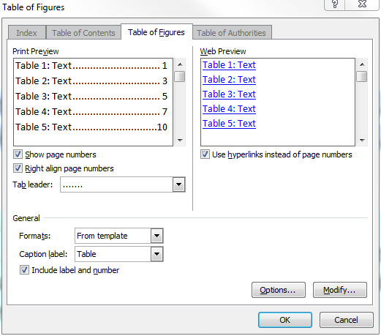

**List of Figures**

Figure 2.1. Dyneema material (a) single layer (4-plies) and (b) representative sample from a thermopressed composite panel 5

Figure 3.1. Typical stress-strain curve from loading-unloading-reloading compression test 6

Figure 4.1. FE model of the hip stem 7

Figure 4.2. Displacement countours for (a) Hyperelastic-Isotropic material model (b) Hyperelastic-orthotropic material model 7

**Tip: Inserting List of Figures**

To insert the List of Figures, position the cursor at the beginning of the line below the heading and invoke the ***Insert Table of Figures*** command from the **References** menu. Ensure that the *Caption Label* is Figure. If the list is not updated, delete the contents completely and then insert.

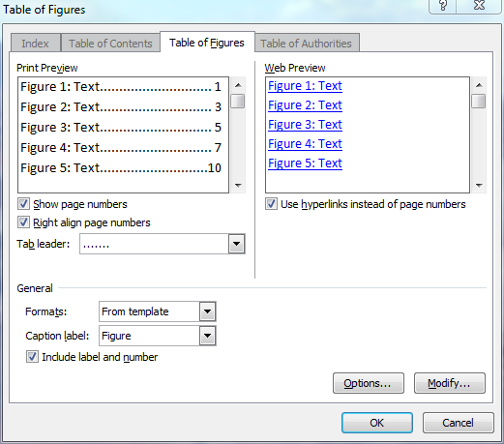

# Introduction

**Tip: Installing Search Command**

It is very helpful to install the Search Command menu option - download from http://www.officelabs.com/projects/searchcommands/Pages/default.aspx. Most of the tips discussed in this document use the Search command to invoke the appropriate command or dialog box from which the command can be customized.

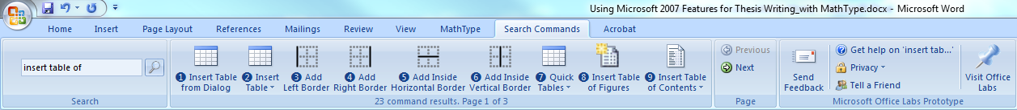

**Tip: Setting the Style**

1. Choose the *Home* ribbon. The *Style* menu should appear on the left side of the ribbon, with white boxes showing different Styles. If you do not see Heading 1, Heading 2, Heading 3, click the *expand* or *open Style window* icon on the bottom right corner of the Style menu. Scroll through the list until you see the entries for the Headings.

2. In the *Styles and Formatting* window (the right-hand window), select *Heading 1* and click the dropdown arrow on the right.

3. Click *Modify*. A window should pop up. In this window you will modify the style of your *Heading 1*. Once you choose the font type (use the same font face as the rest of the text), size, and style, this should be applied consistently to any heading you select to be a *Heading 1*.

To add the word Chapter to Heading 1, choose the *Home* ribbon. Select *Multilevel List* from Paragraph and select the style you want.

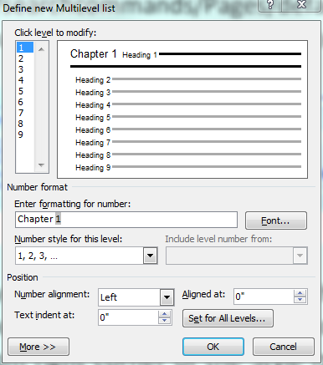

Repeat the above process for all other styles.

**Tip: Numbering the Pages**

This is the introductory chapter. Pages are renumbered from here starting at 1. Note that a section break is inserted immediately after List of Figures so that this renumbering is possible. The first section has Roman numerals[1] for page numbers and this section has the regular (Hindu-Arabic[2]) numbering scheme.

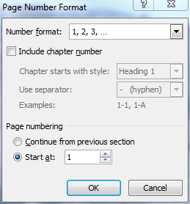

**Tip: Adding References**

Here is an example.

Ultra High Molecular Weight Polyethylene (UHMWPE) materials are widely used in ballistic applications because of their low weight, high tenacity and high specific modulus. These materials have unidirectional construction in which the fibers lie parallel to each other unlike fabrics that are woven. A thermoplastic resin is used as the binding agent. Typically, the material used for armor applications is made up of several 0-90 layers (or plies). The two most popular examples of UHMWPE material are Spectra↓ manufactured by Honeywell[3] and Dyneema↓ manufactured by DSM[4]. The UHMWPE fibers have a modulus in the range of 90-140 GPa and a failure strain of 2.9-3.8%[5]. These fibers have a very high energy absorption capability and high sonic velocity compared to aramid, S2-glass, polyamide and similar materials. The excellent ballistic performance of commercially available material is directly related to these properties. While UHMWPE materials have been in use for a long time, there is very little information available in the public domain on the constitutive model of such materials enabling its use as a predictive tool in the design of armor products.

In the above paragraph, the references were inserted using *Insert Endnote* feature. You should bring up the Insert Endnote dialog to change the default numbering scheme from Roman numerals to Hindu-Arabic numerals.

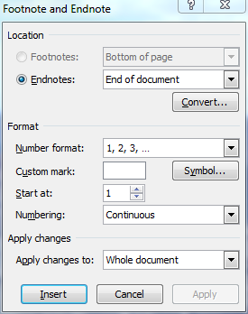

To refer to a reference article after it is introduced in the document, do the following. I will refer to a previous reference once again here3. This can be done by first positioning the cursor at the correct location, then using the *Insert Cross-reference* command. Select the appropriate reference type (endnote) and turning on the *Insert as hyperlink* option. When you *Control+Click* any reference, you are taken to the first reference in the document.

**Tip: Adding Table Titles**

Position the cursor above the table and invoke the ***Insert Caption*** command. Make sure that *Label* is Table.

|  |  |
| --- | --- |
|  |  |

Table .. Use this Checklist Please

|  |  |  |
| --- | --- | --- |
| **Item** | **Remarks** | **Status** |
| 1 | Selected a journal paper for writing style? Is this style acceptable? The style will effect how you show and reference figures, tables, bibliography etc. |  |
| 2 | Do you have a detailed table of contents? |  |
| 3 | Use third person style of writing. Avoided phrases such as “we…” or “I …”? |  |
| 4 | Have you called out all figures and tables with table and figure numbers? |  |
| 5 | Correct number of significant digits in text and tables? |  |
| 6 | Units displayed in all tables and figures? |  |
| 7 | Consistent style in referring to figures: Fig. x or Figure x at the beginning of a sentence; fig. x or figure x in the middle of a sentence. Consistent style in referring to tables: Table x at the beginning of a sentence; table x in the middle of a sentence. |  |
| 8 | Figure captions are consistent over the entire document? |  |
| 9 | Table headings are consistent over the entire document? |  |
| 10 | Table of Contents updated? |  |
| 11 | List of Figures updated? |  |
| 12 | Table of Contents updated? |  |
| 13 | Correct tense used. Present tense for current work. Past tense when referring to previous work. |  |
| 14 | Consistent usage, e.g. LS-DYNA in every use, not a mix of LS-DYNA and LS DYNA, LG404 not a mix of LG404 and LG 404. |  |
| 15 | Avoid using exponent style, e.g. 7.211e6. Use 7.211x106 instead. |  |
| 16 | Spell checked entire document? |  |
| 17 | Subject and verb in sentences are consistent (rather than subject and verb in sentences is consistent!). Pay attention to MS Word’s flagging of errors in syntax and style. |  |
| 18 | Avoid run on sentences. Split very long sentences to two or more short sentences. |  |
| 19 | Paragraphs start at proper locations and are indented? |  |
| 20 | Are only proper nouns capitalized? |  |
| 21 | Do you know when to use bullets and when to use a numbering scheme when showing a list? Is this style used consistently? |  |
| 22 | Have commas (,) been used when required? |  |
| 23 | Do you know the difference between “which” and “that”? Are you using the words consistently? |  |
| 24 | Do you understand what redundant phrases are? Avoid them. |  |
| 25 | Have you defined abbreviations before using them? Once defined, do you use the abbreviations consistently? Use a table of abbreviations at the beginning of the document as well as a page with nomenclature. |  |
| 26 | When inserting figures from another software make sure that the background and foreground colors, fonts etc. are legible in the Word document. |  |
| 27 | Windows 7 and 8 have a very nice program called Snipping Tool that can be used to copy and paste from other applications. |  |
| 31 | Use tables (with no border) to format complicated figures and figure captions. |  |

# Experimental Procedures

This is the second chapter.

## 2.1 UHMWPE Material

This material is good when it works.

**Tip: Adding Figure Titles**

Position the cursor below the figure and invoke the ***Insert Caption*** command. Make sure that *Label* is Figure. Type in the figure title. You can customize the numbering style by clicking on Numbering button.

|  |  |
| --- | --- |
|  |  |

|  |  |
| --- | --- |
| Single layer Dyneema  (a) | Thermopressed  (b) |

Figure .. Dyneema material (a) single layer (4-plies) and (b) representative sample from a thermopressed composite panel

You can insert a cross-reference to the figure: Figure 2.1 shows the unprocessed and processed samples.

# Analytical & Numerical Models

This is the third chapter.

## 3.1 Compression Tests

If you look at , you will see the typical stress-strain curve.

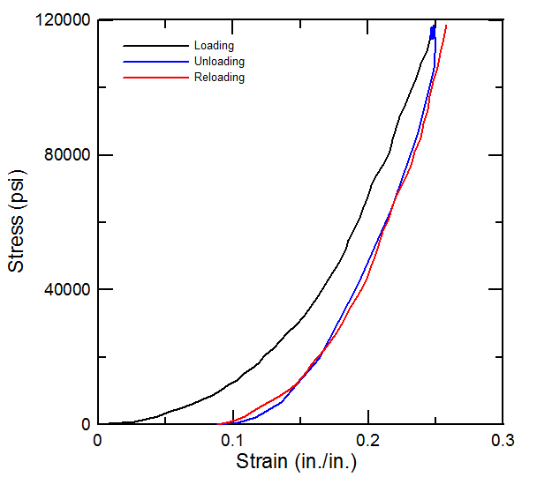

Figure .. Typical stress-strain curve from loading-unloading-reloading compression test

## 3.2 Delamination Tests

The delamination results are shown in Table 3.1.

Table .. Results of Delamination Test (Sample HB26_D1)

|  |  |  |  |  |  |
| --- | --- | --- | --- | --- | --- |
| **Time**  **(s)** | **Opening Displacement**  **(in, cm)** | **Load**  **(lb, N)** | **Width**  **(in, cm)** | **Crack length**  **(in, cm)** | **GIc**  **(lb/in, N/cm)** |
| 1350 | 4.4312, 11.255 | 9.8375, 43.76 | 1.0, 2.54 | 2.8740, 7.3 | 22.36, 39.16 |
| 1440 | 4.7241, 12.0 | 6.7859, 30.184 | 1.0, 2.54 | 2.9527, 7.5 | 16.01, 28.04 |
| 1500 | 4.9226, 12.503 | 10.4760, 46.597 | 1.0, 2.54 | 3.0708, 7.8 | 24.78, 43.39 |
| 1590 | 5.2122, 13.239 | 9.4792, 42.164 | 1.0, 2.54 | 3.2283, 8.2 | 22.60, 39.58 |
| 1650 | 5.4139, 13.7513 | 13.7070, 60.969 | 1.0, 2.54 | 3.4645, 8.8 | 31.67, 55.46 |
| 1710 | 5.6092, 14.2474 | 8.7723, 39.019 | 1.0, 2.54 | 3.6220, 9.2 | 20.10, 35.20 |

# Numerical Results

This is the fourth chapter.

## 4.1 FE Model of Hip Stem

The finite element model of the hip stem is shown in Figure 4.1.

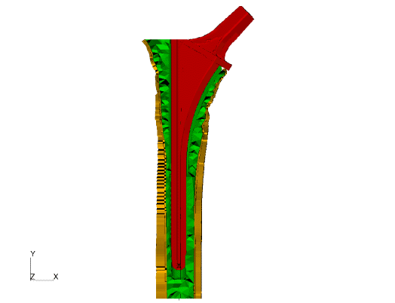

Figure .. FE model of the hip stem

## 4.2 FE Model of LASIK Surgery

Two different constitutive models are shown in Figure 4.2.

|  |  |
| --- | --- |
| (a) | (b) |

Figure .. Displacement countours for (a) Hyperelastic-Isotropic material model (b) Hyperelastic-orthotropic material model

# Concluding Remarks

This is the last chapter. All done.

**References**

1. http://en.wikipedia.org/wiki/Roman_numerals
2. http://en.wikipedia.org/wiki/Arabic_numerals
3. Bhatnagar, A. *Ed.* (2006). Lightweight Ballistic Composites: Military and Law-Enforcement Applications, CRC Press.
4. DSM Dyneema (2009), <http://www.dyneema.com>.
5. Jacobs, M.J.N and Van Dingenen, J.L.J (2001). Ballistic protection mechanisms in personal armour, *Journal of Materials Science*, 36, 3137-3142.